Finding Result
Preparation presentation implementation insight for client has been As Week 7 progresses COIT 20265 IDS project .
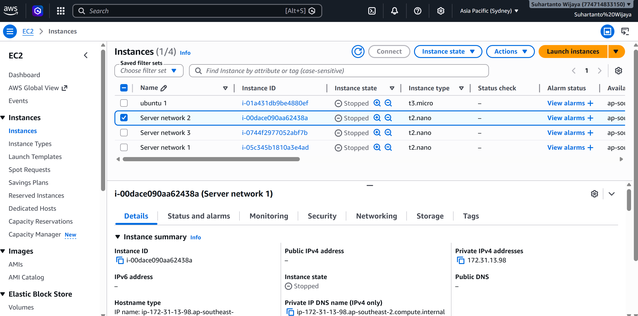
Figure 1. EC2 Instances
Figure 1 , shows Virtual machine has been created by using AWS as cloud provider in order to able detect intrusions 24/7 hours in client network. There are packages has been installed in main network server and sensor networks , as follow :
- Main Server: Streamlit, paho-mqtt,pandas,scikit-learn, seaborn,numpy, influxdb3 and python3
- Sensor Network : Streamlit,paho-mqtt and influxdb3
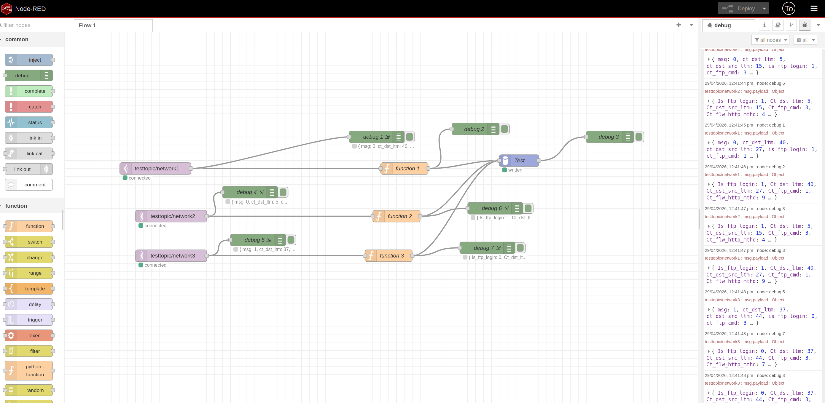
Figure 2. Node-Red Application
Also in figure 2 shows, node-red application has been installed in main network EC2 in order to be able received MQTT protocol from 3 sensor EC2 , written incoming data and collected into DBMS (database management system) .
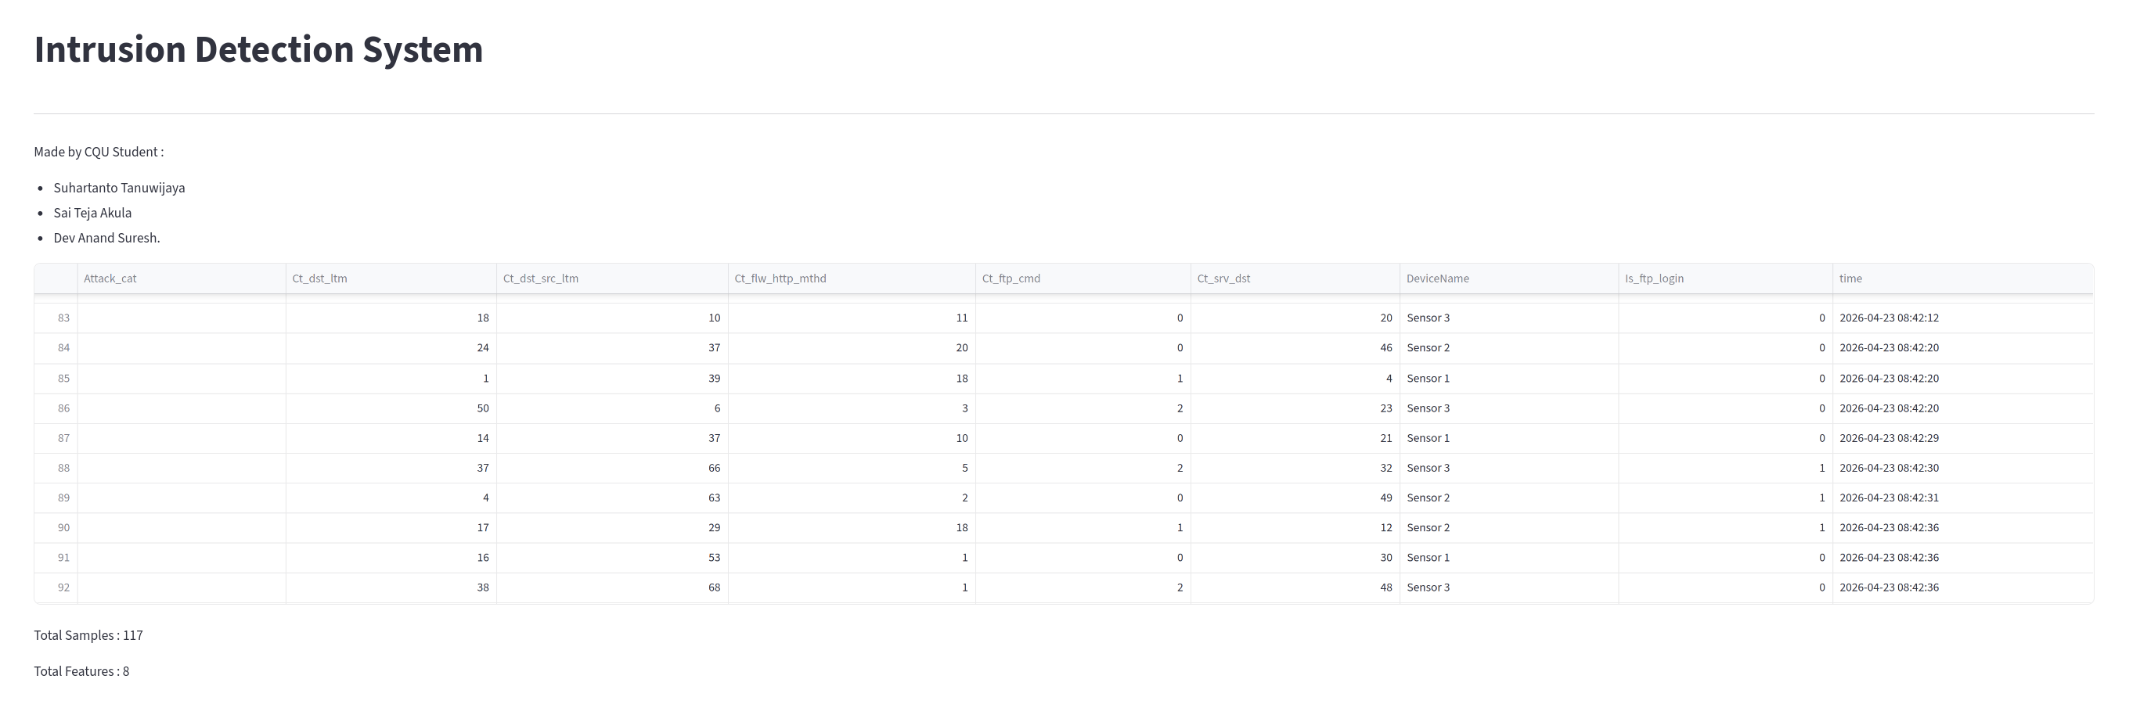
Figure 3. Data Collection
Figure 3 shows, The IDS application system has working and showing captured incoming network traffic data from each sensor EC2 including with captured time.
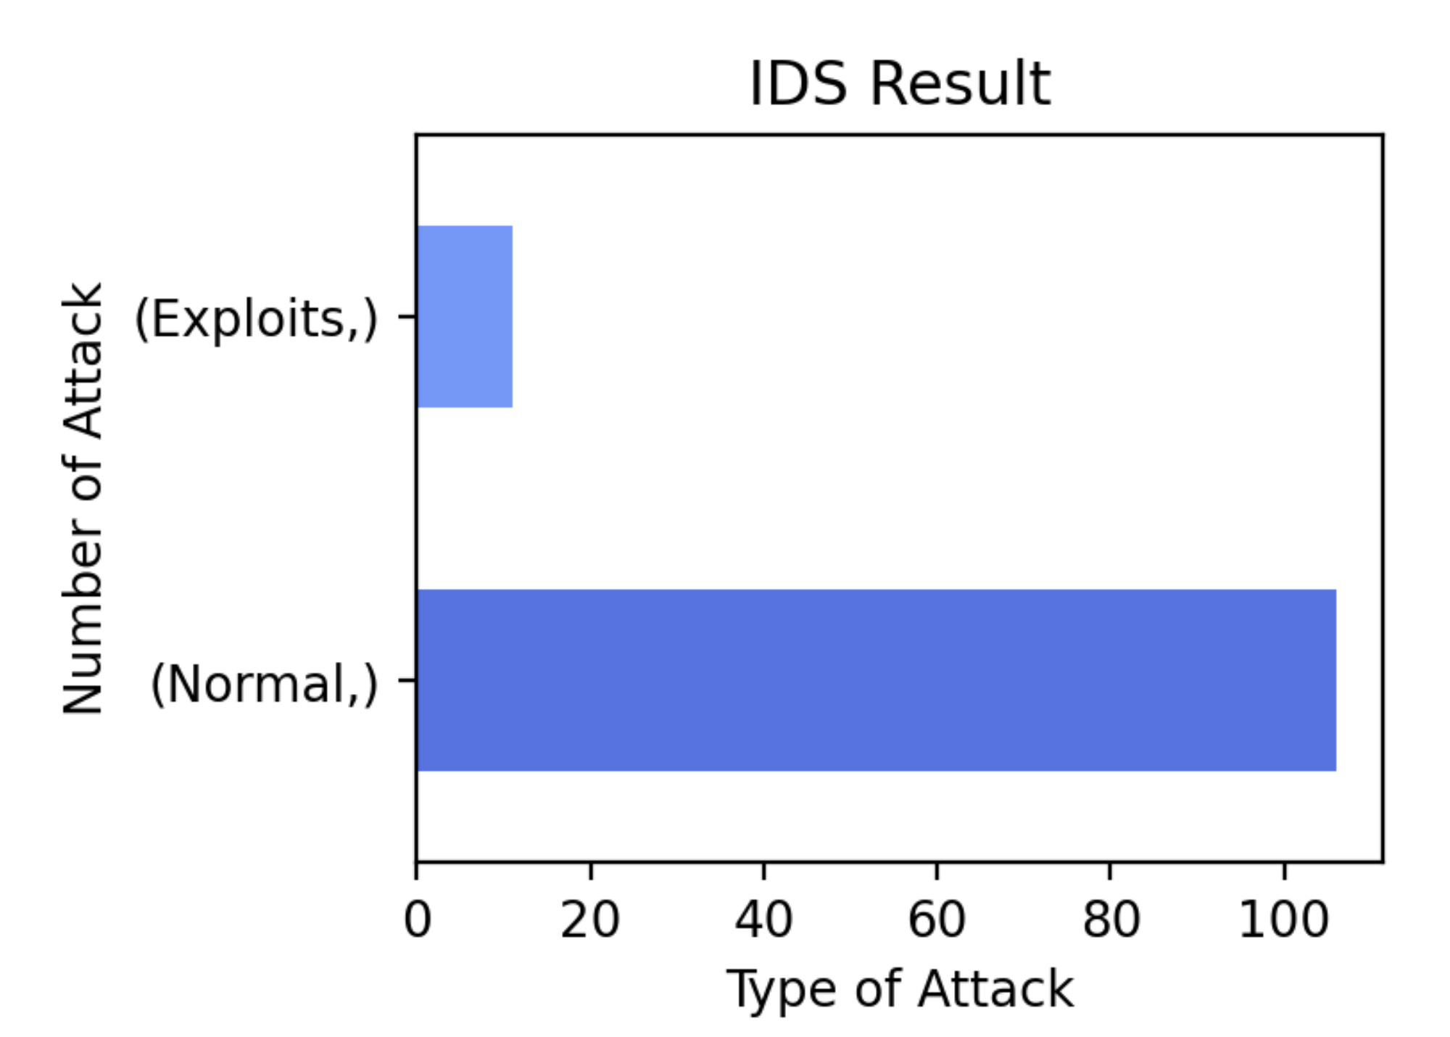
Figure 4. Detection Result
Following last week analysis regarding machine learning model has been developed, figure 4 showing the machine has been succeed to detects traffic either normal, exploits or DoS. Based on result pilot test has been conducted by using 117 sample, detected there are 100 traffic has been categorized by machine into normal , 17 sample as exploits and 0 for DoS intrusion.

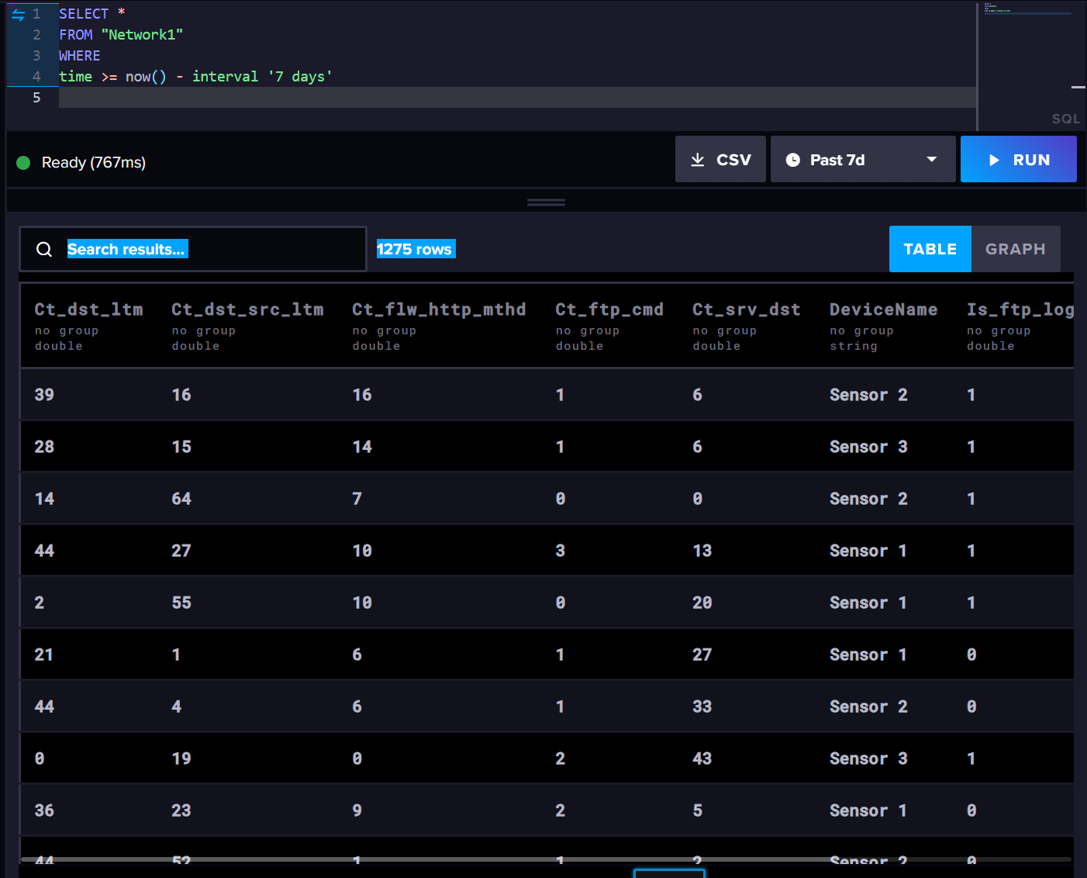
Figure 5. InfluxDB Query
Figure 5 showing , InfluxDB has been using as DBMS for this project , able to export incoming traffic into CSV file , visuals into several graphs and call data based on executed SQL queries.
Network Diagram IDS
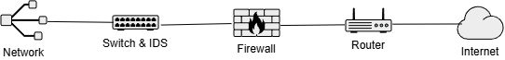
Figure 6. IDS Diagram
Figure 6 shows, the concept implementation for (IDS) Intrusion Detection System would be implemented based on shown figure.

Random Forest Model

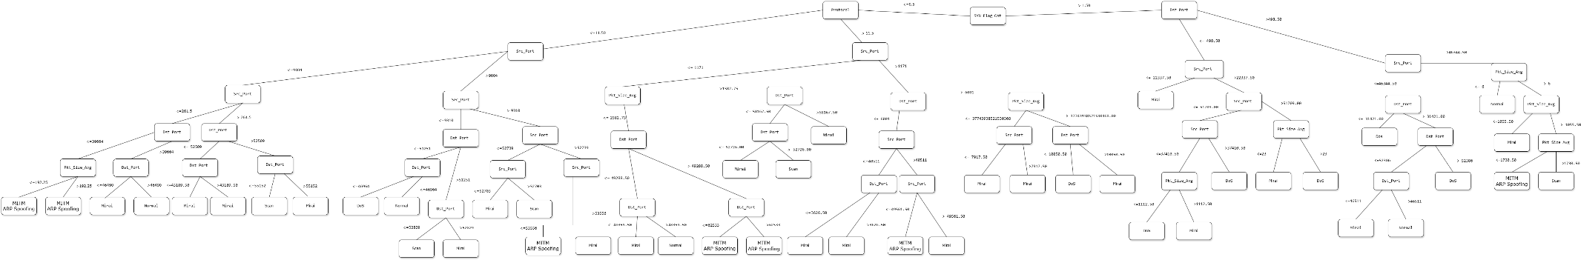
Figure 7. Decision Tree Diagram Test 1
Figure 7 shows, decision tree model has been created by using IoTID20 dataset and 6 features has been taken , which are Dst_Port,Source_port,Pkt_Size_Avg,Protocol, SYN_flag_Cnt and ACK_Flag_Cnt.

Source Code

IDS Web Application
from sklearn.model_selection import cross_val_score
import io
import re
from collections.abc import Iterable
import pandas as pd
from sklearn import tree
from sklearn.model_selection import train_test_split
from sklearn.tree import DecisionTreeClassifier
from sklearn.tree import export_text
import streamlit as st
from pandas.api.types import (is_bool_dtype, is_datetime64_any_dtype,is_numeric_dtype)
import time
import pandas as pd
import matplotlib.pyplot as plt
import seaborn as sns
import warnings
warnings.filterwarnings('ignore')
from sklearn.model_selection import train_test_split
from sklearn.ensemble import RandomForestClassifier
from sklearn.preprocessing import LabelEncoder, StandardScaler
from sklearn.metrics import (
classification_report,
confusion_matrix,
accuracy_score,
roc_curve,
auc
)
import time
from sklearn.datasets import make_classification
import joblib
from sklearn.linear_model import LogisticRegression
from sklearn.datasets import load_iris
import os, time
from influxdb_client_3 import InfluxDBClient3, Point
from paho.mqtt import client as mqtt_client
import random
import time
import json

import numpy as np

def setup_basic():
title = "Intrusion Detection System"

st.set_page_config(
page_title=title,
page_icon="🏆",
layout="wide",
)
st.title(title)

st.markdown(
"""
---
Made by CQU Student :
- Suhartanto Tanuwijaya
- Sai Teja Akula
- Dev Anand Suresh.
"""
)

def InfluxDB():

org = "CQU"
host = "https://us-east-1-1.aws.cloud2.influxdata.com"

client = InfluxDBClient3(host=host, token="eL95h-pilVCJ3G1rZfB3J26H82XuDjsHPzUSOPjMwHdvQrWun8_gxEFJlonfT4CCHeKqoEKvxNKqR_NNhoOQrw==", org=org,disable_grpc_compression=True)

database="Test"

query = """SELECT *
FROM 'Network2'
WHERE time >= now() - interval '30 days'"""

table = client.query(query=query, database="Test", language='sql')

df1 = table.to_pandas().sort_values(by="time")
df = pd.DataFrame(df1)
st.write(df)

st.markdown(f" Total Samples : {df.shape[0]:,}")
st.markdown(f" Total Features : {df.shape[1] - 1}")

Df_Attack=df['Attack_cat']
Df_is_ftp_login=df['Is_ftp_login']
Df_ct_dst_ltm=df['Ct_dst_ltm']
Df_ct_srv_dst=df['Ct_srv_dst']
Df_Ct_ftp_cmd=df['Ct_ftp_cmd']
Df_Ct_Dst_src_ltm=df['Ct_dst_src_ltm']
Df_Ct_flw_http_mthd=df['Ct_flw_http_mthd']

conditions=[

(Df_ct_srv_dst<= 1.5 ) & (Df_ct_dst_ltm <= 1.5) & (Df_Ct_flw_http_mthd<= 0.5)&(Df_Ct_Dst_src_ltm<= 1.5)&(Df_is_ftp_login<= 0.5),#3
(Df_ct_srv_dst<= 1.5 ) & (Df_ct_dst_ltm <= 1.5) & (Df_Ct_flw_http_mthd<= 2.5)&(Df_Ct_Dst_src_ltm<= 1.5)&(Df_is_ftp_login> 0.5),#1
(Df_ct_srv_dst<= 1.5 ) & (Df_ct_dst_ltm <= 1.5) & (Df_Ct_flw_http_mthd <=2.5)& (Df_Ct_flw_http_mthd >0.5)&(Df_Ct_Dst_src_ltm<= 1.5),#3
(Df_ct_srv_dst<= 1.5 ) & (Df_ct_dst_ltm <= 1.5) & (Df_Ct_flw_http_mthd >2.5)&(Df_Ct_Dst_src_ltm<= 1.5),#1
(Df_ct_srv_dst<= 1.5 ) & (Df_ct_dst_ltm > 1.5) & (Df_ct_dst_ltm <= 2.5) & ( Df_is_ftp_login <= 0.5)&(Df_Ct_Dst_src_ltm<= 1.5)& (Df_Ct_flw_http_mthd <=5),#1
(Df_ct_srv_dst<= 1.5 ) & (Df_ct_dst_ltm > 1.5) & (Df_ct_dst_ltm <= 2.5)&( Df_is_ftp_login <= 0.5)&(Df_Ct_Dst_src_ltm<= 1.5)& (Df_Ct_flw_http_mthd >5),#1
(Df_ct_srv_dst<= 1.5 ) & (Df_ct_dst_ltm > 1.5)& (Df_ct_dst_ltm <= 2.5) & ( Df_is_ftp_login > 0.5)&(Df_Ct_Dst_src_ltm<= 1.5),#1

(Df_ct_srv_dst<= 1.5 ) & (Df_ct_dst_ltm <= 1.5) &(Df_Ct_Dst_src_ltm<= 26)&(Df_Ct_Dst_src_ltm> 1.5),#3
(Df_ct_srv_dst<= 1.5 ) & (Df_ct_dst_ltm <= 2.5) &(Df_Ct_Dst_src_ltm <= 47)&(Df_Ct_Dst_src_ltm> 26),#1
(Df_ct_srv_dst<= 1.5 ) & (Df_ct_dst_ltm <= 1.5) &(Df_Ct_Dst_src_ltm > 47),#3
(Df_ct_srv_dst<= 1.5 ) & (Df_ct_dst_ltm > 1.5) & (Df_ct_dst_ltm <= 2.5)&(Df_Ct_Dst_src_ltm > 1.5)&(Df_Ct_flw_http_mthd <= 0.5)&(Df_Ct_ftp_cmd <= 0.5),#3
(Df_ct_srv_dst<= 1.5 ) & (Df_ct_dst_ltm > 1.5) & (Df_ct_dst_ltm <= 2.5)&(Df_Ct_Dst_src_ltm > 1.5)&(Df_Ct_flw_http_mthd <= 0.5)&(Df_Ct_ftp_cmd > 0.5),#3
(Df_ct_srv_dst<= 1.5 ) & (Df_ct_dst_ltm > 1.5)& (Df_ct_dst_ltm <=2.5) &(Df_Ct_Dst_src_ltm > 1.5)&(Df_Ct_flw_http_mthd <= 1.5),#3
(Df_ct_srv_dst<= 1.5 ) & (Df_ct_dst_ltm > 1.5) & (Df_ct_dst_ltm <= 2.5) &(Df_Ct_Dst_src_ltm > 1.5)&(Df_Ct_flw_http_mthd > 1.5),#1

(Df_ct_srv_dst<= 1.5 ) & (Df_ct_dst_ltm <= 4.5)& (Df_ct_dst_ltm > 2.5) &(Df_Ct_Dst_src_ltm <= 2.5),#1
(Df_ct_srv_dst<= 1.5 ) & (Df_ct_dst_ltm <= 4.5)& (Df_ct_dst_ltm > 2.5) &(Df_Ct_Dst_src_ltm <= 8.5) &(Df_Ct_Dst_src_ltm > 2.5),#3
(Df_ct_srv_dst<= 1.5 ) & (Df_ct_dst_ltm > 4.5) &(Df_Ct_Dst_src_ltm <= 8.5)&(Df_Ct_ftp_cmd <= 0.5),#1
(Df_ct_srv_dst<= 1.5 ) & (Df_ct_dst_ltm > 4.5) &(Df_Ct_Dst_src_ltm <= 8.5)&(Df_Ct_ftp_cmd > 0.5),#1
(Df_ct_srv_dst<= 1.5 ) & (Df_ct_dst_ltm > 2.5) &(Df_Ct_Dst_src_ltm > 8.5)&(Df_Ct_Dst_src_ltm <= 9.5),#2
(Df_ct_srv_dst<= 1.5 ) & (Df_ct_dst_ltm > 2.5)& (Df_ct_dst_ltm <= 4) &(Df_Ct_Dst_src_ltm <= 12)&(Df_Ct_Dst_src_ltm > 9.5),#3
(Df_ct_srv_dst<= 1.5 ) & (Df_ct_dst_ltm > 4) &(Df_Ct_Dst_src_ltm <= 12)&(Df_Ct_Dst_src_ltm > 9.5),#1

(Df_ct_srv_dst<= 1.5 ) & (Df_ct_dst_ltm > 2.5) &(Df_Ct_Dst_src_ltm <= 23.5) &(Df_Ct_Dst_src_ltm > 12),#3
(Df_ct_srv_dst<= 1.5 ) & (Df_ct_dst_ltm > 2.5) &(Df_Ct_Dst_src_ltm > 23.5)&(Df_Ct_Dst_src_ltm <= 28.5),#3
(Df_ct_srv_dst<= 1.5 ) & (Df_ct_dst_ltm > 2.5) &(Df_Ct_Dst_src_ltm > 28.5),#1
(Df_ct_srv_dst > 1.5 ) & (Df_ct_srv_dst <= 2.5) & (Df_ct_dst_ltm <= 1.5) &(Df_Ct_Dst_src_ltm <= 1.5),#1
(Df_ct_srv_dst > 1.5 ) & (Df_ct_srv_dst <= 2.5)&(Df_Ct_Dst_src_ltm <= 1.5)& (Df_ct_dst_ltm > 1.5) &(Df_ct_dst_ltm <=2.5),#1
(Df_ct_srv_dst <= 2.5 ) & (Df_ct_srv_dst > 1.5) & (Df_ct_dst_ltm <= 1.5) &(Df_Ct_Dst_src_ltm > 1.5)&(Df_Ct_Dst_src_ltm <= 3.5),#1
(Df_ct_srv_dst <= 2.5 ) & (Df_ct_srv_dst >1.5)& (Df_ct_dst_ltm <= 2.5)& (Df_ct_dst_ltm > 1.5) &(Df_Ct_Dst_src_ltm > 1.5)&(Df_Ct_Dst_src_ltm <= 3.5),#1
(Df_ct_srv_dst <= 8.5 )& (Df_ct_srv_dst > 2.5) & (Df_ct_dst_ltm <= 2.5) &(Df_Ct_Dst_src_ltm <= 2.5), #1
(Df_ct_srv_dst <= 8.5 ) & (Df_ct_srv_dst > 2.5) & (Df_ct_dst_ltm <= 2.5) &(Df_Ct_Dst_src_ltm > 2.5)&(Df_Ct_Dst_src_ltm <= 3.5), #1

(Df_ct_srv_dst > 8.5 ) & (Df_ct_dst_ltm <= 2.5) &(Df_Ct_Dst_src_ltm <= 1.5), #1
(Df_ct_srv_dst > 8.5 )& (Df_ct_dst_ltm <= 2.5) & (Df_Ct_Dst_src_ltm<= 3.5) &(Df_Ct_Dst_src_ltm > 1.5), #3
(Df_ct_srv_dst > 1.5 ) & (Df_ct_dst_ltm <= 3.5)& (Df_ct_dst_ltm > 2.5) &(Df_Ct_Dst_src_ltm <= 2.5)&(Df_Ct_flw_http_mthd <= 2.5),#1
(Df_ct_srv_dst > 1.5 ) & (Df_ct_dst_ltm <= 3.5)& (Df_ct_dst_ltm > 2.5) &(Df_Ct_Dst_src_ltm <= 2.5)&(Df_Ct_flw_http_mthd > 2.5),#1
(Df_ct_srv_dst <= 14.5 )& (Df_ct_srv_dst > 1.5) & (Df_ct_dst_ltm <= 3.5)& (Df_ct_dst_ltm > 2.5) &(Df_Ct_Dst_src_ltm > 2.5),#1
(Df_ct_srv_dst > 14.5 ) & (Df_ct_dst_ltm <= 3.5) & (Df_ct_dst_ltm > 2.5)&(Df_Ct_Dst_src_ltm > 2.5)&(Df_Ct_Dst_src_ltm <=3.5),#3

(Df_ct_srv_dst <= 22.5 ) &(Df_ct_srv_dst > 1.5 )& (Df_ct_dst_ltm > 3.5) &(Df_Ct_Dst_src_ltm <= 3.5),#1
(Df_ct_srv_dst > 22.5 ) & (Df_ct_dst_ltm > 3.5) &(Df_Ct_Dst_src_ltm <= 3.5),#1
(Df_ct_srv_dst > 25 ) & (Df_ct_dst_ltm > 3.5) &(Df_Ct_Dst_src_ltm <= 2),#3
(Df_ct_srv_dst > 25 ) & (Df_ct_dst_ltm > 3.5)&(Df_Ct_Dst_src_ltm <= 3.5) &(Df_Ct_Dst_src_ltm > 2),#2
(Df_ct_srv_dst > 1.5 ) & (Df_ct_dst_ltm <= 1.5) &(Df_Ct_Dst_src_ltm > 3.5)&(Df_Ct_Dst_src_ltm <= 7.5)& (Df_Ct_flw_http_mthd <= 0.5),#1
(Df_ct_srv_dst > 1.5 ) & (Df_ct_dst_ltm <= 1.5) &(Df_Ct_Dst_src_ltm > 7.5)& (Df_Ct_flw_http_mthd <= 0.5),#1
(Df_ct_srv_dst <= 3.5 ) & (Df_ct_srv_dst > 1.5 )& (Df_ct_dst_ltm <= 1.5) &(Df_Ct_Dst_src_ltm > 3.5)& (Df_Ct_flw_http_mthd > 0.5),#1
(Df_ct_srv_dst > 3.5 ) & (Df_ct_dst_ltm <= 1.5) &(Df_Ct_Dst_src_ltm > 3.5)& (Df_Ct_flw_http_mthd > 0.5),#1
(Df_ct_srv_dst <= 10.5 ) & (Df_ct_srv_dst > 1.5 )& (Df_ct_dst_ltm > 1.5) & (Df_ct_dst_ltm <= 6.5)&(Df_Ct_Dst_src_ltm <= 10.5)&(Df_Ct_Dst_src_ltm > 3.5),#1
(Df_ct_srv_dst > 10.5 ) & (Df_ct_dst_ltm > 1.5) & (Df_ct_dst_ltm <= 6.5)&(Df_Ct_Dst_src_ltm <= 10.5),#3
(Df_ct_srv_dst <= 2.5 ) &(Df_ct_srv_dst > 1.5 )& (Df_ct_dst_ltm > 1.5) & (Df_ct_dst_ltm <= 6.5)&(Df_Ct_Dst_src_ltm > 10.5),#1
(Df_ct_srv_dst > 2.5 ) & (Df_ct_dst_ltm > 1.5)& (Df_ct_dst_ltm <= 6.5) &(Df_Ct_Dst_src_ltm > 10.5),#1

(Df_ct_srv_dst > 1.5 ) & (Df_ct_dst_ltm <= 8.5)& (Df_ct_dst_ltm > 6.5) &(Df_Ct_Dst_src_ltm <= 9.5)&(Df_Ct_Dst_src_ltm > 3.5),#1
(Df_ct_srv_dst > 1.5 ) & (Df_ct_dst_ltm > 8.5) &(Df_Ct_Dst_src_ltm <= 9.5)&(Df_Ct_Dst_src_ltm > 3.5),#1
(Df_ct_srv_dst > 1.5 ) & (Df_ct_dst_ltm <= 9.5) & (Df_ct_dst_ltm > 6.5)&(Df_Ct_Dst_src_ltm > 9.5)&(Df_Ct_Dst_src_ltm <= 14.5),#1
(Df_ct_srv_dst > 1.5 ) & (Df_ct_dst_ltm > 9.5) &(Df_Ct_Dst_src_ltm > 9.5)&(Df_Ct_Dst_src_ltm <= 14.5),#3

(Df_ct_srv_dst > 1.5 ) & (Df_ct_srv_dst <= 2.5 )& (Df_ct_dst_ltm <= 7.5)& (Df_ct_dst_ltm > 6.5) &(Df_Ct_Dst_src_ltm > 14.5),#1
(Df_ct_srv_dst > 1.5 )& (Df_ct_srv_dst <= 2.5 ) & (Df_ct_dst_ltm > 7.5) &(Df_Ct_Dst_src_ltm > 14.5),#3
(Df_ct_srv_dst > 2.5 )& (Df_ct_dst_ltm > 6.5) &(Df_Ct_Dst_src_ltm > 14.5),#1

]

Type_attack=["Exploits","Normal","Exploits","Normal","Normal","Normal","Normal",
"Exploits","Normal","Exploits","Exploits","Exploits","Exploits","Normal",
"Normal","Exploits","Normal","Normal","DoS","Exploits","Normal",
"Exploits","Exploits","Normal","Normal","Normal","Normal","Normal",
"Normal","Normal","Normal","Exploits","Normal","Normal","Normal",
"Exploits","Normal","Normal","Exploits","DoS","Normal","Normal",
"Normal","Normal","Normal","Exploits","Normal","Normal","Normal",
"Normal","Normal","Exploits","Normal","Exploits","Normal"]

result=np.select(conditions,Type_attack)

df_result=pd.DataFrame(result,columns=['Result'])

fig, ax = plt.subplots(figsize=(4, 3))
df_result.value_counts().head(10).plot(
kind='barh', ax=ax,
color=sns.color_palette('coolwarm', 10))
ax.set_xlabel('Type of Attack')
ax.set_ylabel('Number of Attack')
ax.set_title('IDS Result')
plt.tight_layout()
plt.show()
st.pyplot(fig)

broker = 's72d970b.ala.asia-southeast1.emqxsl.com'
port = 8883
topic = 'testtopic/network1'
client_id = f'python-mqtt-{random.randint(0, 1000)}'
username = 'Suhartanto'
password = 'Suhartanto098!'

def connect_mqtt():
def on_connect(client, userdata, flags, rc):
if rc == 0:
st.write("Connected to MQTT Broker!")
else:
st.write("Failed to connect, return code %d\n", rc)
# Set Connecting Client ID
client = mqtt_client.Client(mqtt_client.CallbackAPIVersion.VERSION1,client_id=client_id)
client.tls_set(ca_certs='/home/tanto/Downloads/emqxsl-ca.crt')
client.username_pw_set(username, password)
client.on_connect = on_connect
client.connect(broker, port)

return client

def subscribe(client: mqtt_client):
def on_message(client, userdata, msg):
st.text(f"Received `{msg.payload.decode()}` from `{msg.topic}` topic")

client.subscribe(topic)
client.on_message = on_message

def main():
setup_basic()
InfluxDB()
client = connect_mqtt()
subscribe(client)
client.loop_forever()

if __name__ == "__main__":
main()

Sensor Server
import os, time
from influxdb_client_3 import InfluxDBClient3, Point
from paho.mqtt import client as mqtt_client
import random
import time
import json
import streamlit as st
import pandas as pd
import numpy as np

def setup_basic():
title = "MQTT Sensor 1"

st.set_page_config(
page_title=title,
page_icon="🏆",
layout="wide",
)
st.title(title)

st.markdown(
"""
---
Made by CQU Student :
- Suhartanto Tanuwijaya
- Sai Teja Akula
- Dev Anand Suresh.
"""
)

st.markdown("""\n""")
st.markdown("# MQTT Sensor 1 Start ")

def InfluxDB():
org = "CQU"
host = "https://us-east-1-1.aws.cloud2.influxdata.com"

client = InfluxDBClient3(host=host, token="eL95h-pilVCJ3G1rZfB3J26H82XuDjsHPzUSOPjMwHdvQrWun8_gxEFJlonfT4CCHeKqoEKvxNKqR_NNhoOQrw==", org=org,disable_grpc_compression=True)

database="Test"

query = """SELECT *
FROM 'Network1'
WHERE time >= now() - interval '24 hours'"""

table = client.query(query=query, database="Test", language='sql')

df = table.to_pandas().sort_values(by="time")
st.write(df)

broker = 's72d970b.ala.asia-southeast1.emqxsl.com'
port = 8883
topic = 'testtopic/network1'
client_id = f'python-mqtt-{random.randint(0, 1000)}'
username = 'Suhartanto'
password = 'Suhartanto098!'

def connect_mqtt():
def on_connect(client, userdata, flags, rc):
if rc == 0:
st.write("Connected to MQTT Broker!")
else:
st.write("Failed to connect, return code %d\n", rc)
# Set Connecting Client ID
client = mqtt_client.Client(mqtt_client.CallbackAPIVersion.VERSION1,client_id=client_id)
client.tls_set(ca_certs='/home/tanto/Documents/emqxsl-ca.crt')
client.username_pw_set(username, password)
client.on_connect = on_connect
client.connect(broker, port)
st.markdown("ww")
return client

def publish(client):
msg_count = 0
while True:
time.sleep(5)
msg_dict = {
'msg': msg_count,
"ct_dst_ltm": random.randint(0,50),
"ct_dst_src_ltm": random.randint(0,70),
"is_ftp_login": random.randint(0,1),
"ct_ftp_cmd": random.randint(0,3),
"ct_flw_http_mthd": random.randint(0,20),
"ct_srv_dst": random.randint(0,50),
"attack_cat":"",
"device_name": "Sensor 1"
}

msg = json.dumps(msg_dict)
result = client.publish(topic, msg)
# result: [0, 1]
status = result[0]
if status == 0:
st.write(f'Send `{msg}` to topic `{topic}`')
else:
st.write(f'Failed to send message to topic {topic}')
msg_count += 1
time.sleep(3)

def subscribe(client: mqtt_client):
def on_message(client, userdata, msg):
st.text(f"Received `{msg.payload.decode()}` from `{msg.topic}` topic")

client.subscribe(topic)
client.on_message = on_message

def main():
setup_basic()
InfluxDB()
client = connect_mqtt()
client.loop_start()
publish(client)
time.sleep(3)

if __name__ == "__main__":
main()

